Theme 2022
Engineers & Cushman
“ Airfield Liberation”
5th - 7th August 2022 Airfield E.B.G.G
Veldekensdreef 8 9500 Geraardsbergen

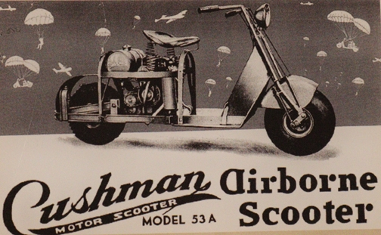
WWII CAMP
“ Airfield liberation”
5 - 7th August 2022 Airfield E.B.G.G
50° 45' 17'' N / 03° 51' 45'' E
Overboelare-Geraardsbergen
Program:
Friday 5^{nd(privat)}
12:00 am arrivals to the camp and building display’s
7:00 pm dinner Pitta &fries
9:00 pm booze, music at the Camp with live performance

Saturday 6^{th(open for public)}
8:00 am wake up & breakfast (Reservations before)
9:30 am lining-up of convoy
10:00 am departure of the Flemish Ardennes Tour (FAT)
2:00 pm return to base camp
Static show
Re-enactment walk !!!!
Air show
Bar Open
Evening Program : Movie night and lots of booze!

Sunday 7^{th(open for public)}
8:00 am wake up & breakfast
9:30 am lining-up of convoy
10:00 am departure of the Dender valley tour (DVT)
14:00 am return to Base camp with drive past in front of the audience
Static show
Re-enactment
Air show
Bar Open

6:00 pm End of the Camp and say goodbye.

Possible to stay till Monday with free breakfast !!!!!!

REGISTER BEFORE 20th of July!!!!!!!!!!!

a great weekend in a unique atmosphere!!!!
2 nice road tours (FAT & DVT)
for re-enactors :Display building, re-enactment walk,…..
Possibility to set up display’s (medic post, radio office, field hospital, barbers shop…)

Friday evening contests (pilots baptism)

Limited power 220V available but bring your own power cables to the connection point.
Camp on luxurious (soft) grass
Good weather can be arranged (max 138°F)

Price list:
Total price for the weekend only 60€
Including :
-Pitta & fries@friday evening
-Hot-Dog on the road
- Saturday pork roast each registered person
(One day = 5€/without food)
Grand total of 60€/pp to be withdrawn on the account number of airfieldliberation : reference = WWII camp + name
IBAN: BE70 7310 4671 0525
BIC: KREDBEBB

Info : www.airfieldliberation.be
airfieldliberation@gmail.com

